K-Nearest Neighbors - Evaluation
Generated: 2026-05-26 12:04:19

Model Summary
Index | Metric | Value
0 | Algorithm | K-Nearest Neighbors
1 | Number of Neighbors | 5
2 | Training Samples | 35
3 | Test Samples | 9
4 | Features | 17
5 | Target Classes | 0, 1, 2, 3, 4, 5, 6

Neighbor Distances (first 10 test cases)
Index | Neighbor 1 | Neighbor 2 | Neighbor 3 | Neighbor 4 | Neighbor 5
0 | 130.71641059943926 | 138.03235128041433 | 302.0999337967443 | 302.239342243866 | 335.6267718761395
1 | 10.58772874647536 | 801.550534900954 | 801.550534900954 | 1361.3883207960896 | 1390.0057553837735
2 | 308.475930989771 | 395.8331971929613 | 429.4096528956918 | 435.20297563320406 | 682.2294262196622
3 | 127.01157427572345 | 188.1446517974838 | 256.9850579314053 | 439.2997382198234 | 630.5460094235697
4 | 82.44804424610176 | 199.12594004800226 | 303.62458727843597 | 488.82891690243184 | 511.3482472835953
5 | 62.90182827230647 | 299.93859371544727 | 307.6174247340332 | 317.6741097414139 | 335.78427598683066
6 | 119.55814485010426 | 168.9522121784781 | 233.10508359964336 | 373.38944816371475 | 540.9603035343694
7 | 78.71842224030901 | 226.58879054356754 | 271.7434451831359 | 393.57745108173236 | 396.34671690327684
8 | 128.85984634477649 | 421.09991688434525 | 469.50805104918317 | 473.9501872560039 | 636.4829927028699

Summary Metrics
Index | Metric | Value
0 | Accuracy | 0.2222222222222222
1 | Balanced Accuracy | 0.25
2 | Macro Precision | 0.21428571428571427
3 | Macro Recall | 0.21428571428571427
4 | Macro F1 Score | 0.19047619047619047
5 | Test Samples | 9.0

Confusion Matrix
Index | Pred_0 | Pred_1 | Pred_2 | Pred_3 | Pred_4 | Pred_5 | Pred_6
Actual_0 | 1 | 0 | 0 | 0 | 0 | 0 | 0
Actual_1 | 0 | 0 | 0 | 0 | 1 | 0 | 1
Actual_2 | 1 | 1 | 0 | 0 | 0 | 0 | 0
Actual_3 | 0 | 0 | 0 | 0 | 1 | 0 | 0
Actual_4 | 0 | 0 | 0 | 0 | 0 | 0 | 1
Actual_5 | 0 | 0 | 0 | 0 | 1 | 1 | 0
Actual_6 | 0 | 0 | 0 | 0 | 0 | 0 | 0

Classification Report
Index | precision | recall | f1-score | support
0 | 0.5 | 1.0 | 0.6666666666666666 | 1.0
1 | 0.0 | 0.0 | 0.0 | 2.0
2 | 0.0 | 0.0 | 0.0 | 2.0
3 | 0.0 | 0.0 | 0.0 | 1.0
4 | 0.0 | 0.0 | 0.0 | 1.0
5 | 1.0 | 0.5 | 0.6666666666666666 | 2.0
6 | 0.0 | 0.0 | 0.0 | 0.0
accuracy | 0.2222222222222222 | 0.2222222222222222 | 0.2222222222222222 | 0.2222222222222222
macro avg | 0.21428571428571427 | 0.21428571428571427 | 0.19047619047619047 | 9.0
weighted avg | 0.2777777777777778 | 0.2222222222222222 | 0.2222222222222222 | 9.0

Test Set Predictions
Index | Index | Actual | Predicted
0 | 85 | 2 | 0
1 | 53 | 2 | 1
2 | 57 | 1 | 6
3 | 83 | 4 | 6
4 | 77 | 5 | 4
5 | 93 | 3 | 4
6 | 9 | 1 | 4
7 | 27 | 0 | 0
8 | 17 | 5 | 5

Visualizations
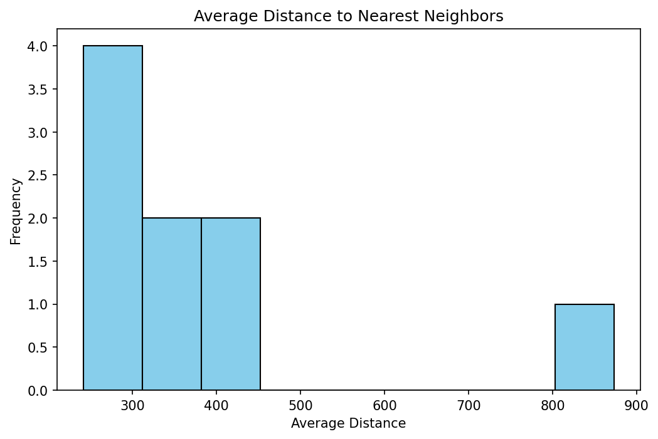
Figure 1

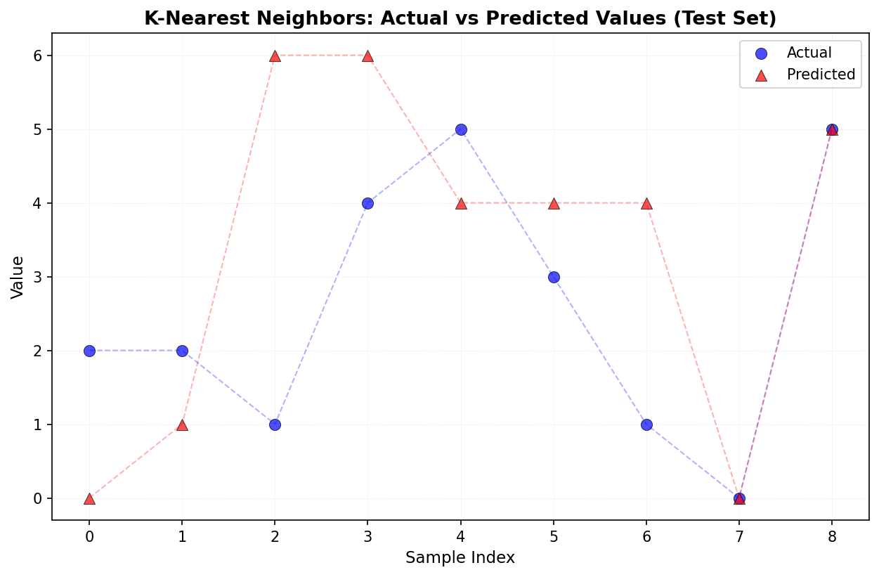
Figure 2

